**PPS MINI PROJECT**

**BANK MANAGEMENT SYSTEM**

**Shaurya Srinet**

**RA2111032010006**

**CSE IOT U2**

**SYNOPSIS**

In this project, you can create a new account, update information of an existing account, view and manage transactions, check the details of an existing account, remove existing account and view customers’ list.

Overall, with this project, you can perform banking activities like in a REAL bank. Bank management mini project in C is a console application without graphics. It is compiled in Code::Blocks with gcc compiler.

The source code is password protected

(password is 1234).

In this bank management system project in C, file handling has been used for almost all functions. File has been used to store data related to new account, transaction, editing of account information and viewing of account information.

**SOURCE CODE**

#include<stdio.h>

#include<stdlib.h>

#include<windows.h>

int i,j;

int main_exit;

void menu();

struct date{

int month,day,year;

};

struct {

char name[60];

int acc_no,age;

char address[60];

char citizenship[15];

double phone;

char acc_type[10];

float amt;

struct date dob;

struct date deposit;

struct date withdraw;

}add,upd,check,rem,transaction;

float interest(float t,float amount,int rate)

{

float SI;

SI=(rate*t*amount)/100.0;

return (SI);

}

void fordelay(int j)

{ int i,k;

for(i=0;i<j;i++)

k=i;

}

void new_acc()

{

int choice;

FILE *ptr;

ptr=fopen("record.dat","a+");

account_no:

system("cls");

printf("\t\t\t\xB2\xB2\xB2\ ADD RECORD \xB2\xB2\xB2\xB2");

printf("\n\n\nEnter today's date(dd/mm/yyyy):");

scanf("%d/%d/%d",&add.deposit.month,&add.deposit.day,&add.deposit.year);

printf("\nEnter the account number:");

scanf("%d",&check.acc_no);

while(fscanf(ptr,"%d %s %d/%d/%d %d %s %s %lf %s %f %d/%d/%d\n",&add.acc_no,add.name,&add.dob.month,&add.dob.day,&add.dob.year,&add.age,add.address,add.citizenship,&add.phone,add.acc_type,&add.amt,&add.deposit.month,&add.deposit.day,&add.deposit.year)!=EOF)

{

if (check.acc_no==add.acc_no)

{printf("Account no. already in use!");

fordelay(1000000000);

goto account_no;

}

}

add.acc_no=check.acc_no;

printf("\nEnter the name:");

scanf("%s",add.name);

printf("\nEnter the date of birth(dd/mm/yyyy):");

scanf("%d/%d/%d",&add.dob.month,&add.dob.day,&add.dob.year);

printf("\nEnter the age:");

scanf("%d",&add.age);

printf("\nEnter the address:");

scanf("%s",add.address);

printf("\nEnter the citizenship number:");

scanf("%s",add.citizenship);

printf("\nEnter the phone number: ");

scanf("%lf",&add.phone);

printf("\nEnter the amount to deposit:$");

scanf("%f",&add.amt);

printf("\nType of account:\n\t#Saving\n\t#Current\n\t#Fixed1(for 1 year)\n\t#Fixed2(for 2 years)\n\t#Fixed3(for 3 years)\n\n\tEnter your choice:");

scanf("%s",add.acc_type);

fprintf(ptr,"%d %s %d/%d/%d %d %s %s %lf %s %f %d/%d/%d\n",add.acc_no,add.name,add.dob.month,add.dob.day,add.dob.year,add.age,add.address,add.citizenship,add.phone,add.acc_type,add.amt,add.deposit.month,add.deposit.day,add.deposit.year);

fclose(ptr);

printf("\nAccount created successfully!");

add_invalid:

printf("\n\n\n\t\tEnter 1 to go to the main menu and 0 to exit:");

scanf("%d",&main_exit);

system("cls");

if (main_exit==1)

menu();

else if(main_exit==0)

close();

else

{

printf("\nInvalid!\a");

goto add_invalid;

}

}

void view_list()

{

FILE *view;

view=fopen("record.dat","r");

int test=0;

system("cls");

printf("\nACC. NO.\tNAME\t\t\tADDRESS\t\t\tPHONE\n");

while(fscanf(view,"%d %s %d/%d/%d %d %s %s %lf %s %f %d/%d/%d",&add.acc_no,add.name,&add.dob.month,&add.dob.day,&add.dob.year,&add.age,add.address,add.citizenship,&add.phone,add.acc_type,&add.amt,&add.deposit.month,&add.deposit.day,&add.deposit.year)!=EOF)

{

printf("\n%6d\t %10s\t\t\t%10s\t\t%.0lf",add.acc_no,add.name,add.address,add.phone);

test++;

}

fclose(view);

if (test==0)

{ system("cls");

printf("\nNO RECORDS!!\n");}

view_list_invalid:

printf("\n\nEnter 1 to go to the main menu and 0 to exit:");

scanf("%d",&main_exit);

system("cls");

if (main_exit==1)

menu();

else if(main_exit==0)

close();

else

{

printf("\nInvalid!\a");

goto view_list_invalid;

}

}

void edit(void)

{

int choice,test=0;

FILE *old,*newrec;

old=fopen("record.dat","r");

newrec=fopen("new.dat","w");

printf("\nEnter the account no. of the customer whose info you want to change:");

scanf("%d",&upd.acc_no);

while(fscanf(old,"%d %s %d/%d/%d %d %s %s %lf %s %f %d/%d/%d",&add.acc_no,add.name,&add.dob.month,&add.dob.day,&add.dob.year,&add.age,add.address,add.citizenship,&add.phone,add.acc_type,&add.amt,&add.deposit.month,&add.deposit.day,&add.deposit.year)!=EOF)

{

if (add.acc_no==upd.acc_no)

{ test=1;

printf("\nWhich information do you want to change?\n1.Address\n2.Phone\n\nEnter your choice(1 for address and 2 for phone):");

scanf("%d",&choice);

system("cls");

if(choice==1)

{printf("Enter the new address:");

scanf("%s",upd.address);

fprintf(newrec,"%d %s %d/%d/%d %d %s %s %lf %s %f %d/%d/%d\n",add.acc_no,add.name,add.dob.month,add.dob.day,add.dob.year,add.age,upd.address,add.citizenship,add.phone,add.acc_type,add.amt,add.deposit.month,add.deposit.day,add.deposit.year);

system("cls");

printf("Changes saved!");

}

else if(choice==2)

{

printf("Enter the new phone number:");

scanf("%lf",&upd.phone);

fprintf(newrec,"%d %s %d/%d/%d %d %s %s %lf %s %f %d/%d/%d\n",add.acc_no,add.name,add.dob.month,add.dob.day,add.dob.year,add.age,add.address,add.citizenship,upd.phone,add.acc_type,add.amt,add.deposit.month,add.deposit.day,add.deposit.year);

system("cls");

printf("Changes saved!");

}

}

else

fprintf(newrec,"%d %s %d/%d/%d %d %s %s %lf %s %f %d/%d/%d\n",add.acc_no,add.name,add.dob.month,add.dob.day,add.dob.year,add.age,add.address,add.citizenship,add.phone,add.acc_type,add.amt,add.deposit.month,add.deposit.day,add.deposit.year);

}

fclose(old);

fclose(newrec);

remove("record.dat");

rename("new.dat","record.dat");

if(test!=1)

{ system("cls");

printf("\nRecord not found!!\a\a\a");

edit_invalid:

printf("\nEnter 0 to try again,1 to return to main menu and 2 to exit:");

scanf("%d",&main_exit);

system("cls");

if (main_exit==1)

menu();

else if (main_exit==2)

close();

else if(main_exit==0)

edit();

else

{printf("\nInvalid!\a");

goto edit_invalid;}

}

else

{printf("\n\n\nEnter 1 to go to the main menu and 0 to exit:");

scanf("%d",&main_exit);

system("cls");

if (main_exit==1)

menu();

else

close();

}

}

void transact(void)

{ int choice,test=0;

FILE *old,*newrec;

old=fopen("record.dat","r");

newrec=fopen("new.dat","w");

printf("Enter the account no. of the customer:");

scanf("%d",&transaction.acc_no);

while (fscanf(old,"%d %s %d/%d/%d %d %s %s %lf %s %f %d/%d/%d",&add.acc_no,add.name,&add.dob.month,&add.dob.day,&add.dob.year,&add.age,add.address,add.citizenship,&add.phone,add.acc_type,&add.amt,&add.deposit.month,&add.deposit.day,&add.deposit.year)!=EOF)

{

if(add.acc_no==transaction.acc_no)

{ test=1;

if(strcmpi(add.acc_type,"fixed1")==0||strcmpi(add.acc_type,"fixed2")==0||strcmpi(add.acc_type,"fixed3")==0)

{

printf("\a\a\a\n\nYOU CANNOT DEPOSIT OR WITHDRAW CASH IN FIXED ACCOUNTS!!!!!");

fordelay(1000000000);

system("cls");

menu();

}

printf("\n\nDo you want to\n1.Deposit\n2.Withdraw?\n\nEnter your choice(1 for deposit and 2 for withdraw):");

scanf("%d",&choice);

if (choice==1)

{

printf("Enter the amount you want to deposit:$ ");

scanf("%f",&transaction.amt);

add.amt+=transaction.amt;

fprintf(newrec,"%d %s %d/%d/%d %d %s %s %lf %s %f %d/%d/%d\n",add.acc_no,add.name,add.dob.month,add.dob.day,add.dob.year,add.age,add.address,add.citizenship,add.phone,add.acc_type,add.amt,add.deposit.month,add.deposit.day,add.deposit.year);

printf("\n\nDeposited successfully!");

}

else

{

printf("Enter the amount you want to withdraw:$ ");

scanf("%f",&transaction.amt);

add.amt-=transaction.amt;

fprintf(newrec,"%d %s %d/%d/%d %d %s %s %lf %s %f %d/%d/%d\n",add.acc_no,add.name,add.dob.month,add.dob.day,add.dob.year,add.age,add.address,add.citizenship,add.phone,add.acc_type,add.amt,add.deposit.month,add.deposit.day,add.deposit.year);

printf("\n\nWithdrawn successfully!");

}

}

else

{

fprintf(newrec,"%d %s %d/%d/%d %d %s %s %lf %s %f %d/%d/%d\n",add.acc_no,add.name,add.dob.month,add.dob.day,add.dob.year,add.age,add.address,add.citizenship,add.phone,add.acc_type,add.amt,add.deposit.month,add.deposit.day,add.deposit.year);

}

}

fclose(old);

fclose(newrec);

remove("record.dat");

rename("new.dat","record.dat");

if(test!=1)

{

printf("\n\nRecord not found!!");

transact_invalid:

printf("\n\n\nEnter 0 to try again,1 to return to main menu and 2 to exit:");

scanf("%d",&main_exit);

system("cls");

if (main_exit==0)

transact();

else if (main_exit==1)

menu();

else if (main_exit==2)

close();

else

{

printf("\nInvalid!");

goto transact_invalid;

}

}

else

{

printf("\nEnter 1 to go to the main menu and 0 to exit:");

scanf("%d",&main_exit);

system("cls");

if (main_exit==1)

menu();

else

close();

}

}

void erase(void)

{

FILE *old,*newrec;

int test=0;

old=fopen("record.dat","r");

newrec=fopen("new.dat","w");

printf("Enter the account no. of the customer you want to delete:");

scanf("%d",&rem.acc_no);

while (fscanf(old,"%d %s %d/%d/%d %d %s %s %lf %s %f %d/%d/%d",&add.acc_no,add.name,&add.dob.month,&add.dob.day,&add.dob.year,&add.age,add.address,add.citizenship,&add.phone,add.acc_type,&add.amt,&add.deposit.month,&add.deposit.day,&add.deposit.year)!=EOF)

{

if(add.acc_no!=rem.acc_no)

fprintf(newrec,"%d %s %d/%d/%d %d %s %s %lf %s %f %d/%d/%d\n",add.acc_no,add.name,add.dob.month,add.dob.day,add.dob.year,add.age,add.address,add.citizenship,add.phone,add.acc_type,add.amt,add.deposit.month,add.deposit.day,add.deposit.year);

else

{test++;

printf("\nRecord deleted successfully!\n");

}

}

fclose(old);

fclose(newrec);

remove("record.dat");

rename("new.dat","record.dat");

if(test==0)

{

printf("\nRecord not found!!\a\a\a");

erase_invalid:

printf("\nEnter 0 to try again,1 to return to main menu and 2 to exit:");

scanf("%d",&main_exit);

if (main_exit==1)

menu();

else if (main_exit==2)

close();

else if(main_exit==0)

erase();

else

{printf("\nInvalid!\a");

goto erase_invalid;}

}

else

{printf("\nEnter 1 to go to the main menu and 0 to exit:");

scanf("%d",&main_exit);

system("cls");

if (main_exit==1)

menu();

else

close();

}

}

void see(void)

{

FILE *ptr;

int test=0,rate;

int choice;

float time;

float intrst;

ptr=fopen("record.dat","r");

printf("Do you want to check by\n1.Account no\n2.Name\nEnter your choice:");

scanf("%d",&choice);

if (choice==1)

{ printf("Enter the account number:");

scanf("%d",&check.acc_no);

while (fscanf(ptr,"%d %s %d/%d/%d %d %s %s %lf %s %f %d/%d/%d",&add.acc_no,add.name,&add.dob.month,&add.dob.day,&add.dob.year,&add.age,add.address,add.citizenship,&add.phone,add.acc_type,&add.amt,&add.deposit.month,&add.deposit.day,&add.deposit.year)!=EOF)

{

if(add.acc_no==check.acc_no)

{ system("cls");

test=1;

printf("\nAccount NO.:%d\nName:%s \nDOB:%d/%d/%d \nAge:%d \nAddress:%s \nCitizenship No:%s \nPhone number:%.0lf \nType Of Account:%s \nAmount deposited:$ %.2f \nDate Of Deposit:%d/%d/%d\n\n",add.acc_no,add.name,add.dob.month,add.dob.day,add.dob.year,add.age,add.address,add.citizenship,add.phone,

add.acc_type,add.amt,add.deposit.month,add.deposit.day,add.deposit.year);

if(strcmpi(add.acc_type,"fixed1")==0)

{

time=1.0;

rate=9;

intrst=interest(time,add.amt,rate);

printf("\n\nYou will get $%.2f as interest on %d/%d/%d",intrst,add.deposit.month,add.deposit.day,add.deposit.year+1);

}

else if(strcmpi(add.acc_type,"fixed2")==0)

{

time=2.0;

rate=11;

intrst=interest(time,add.amt,rate);

printf("\n\nYou will get $.%.2f as interest on %d/%d/%d",intrst,add.deposit.month,add.deposit.day,add.deposit.year+2);

}

else if(strcmpi(add.acc_type,"fixed3")==0)

{

time=3.0;

rate=13;

intrst=interest(time,add.amt,rate);

printf("\n\nYou will get $.%.2f as interest on %d/%d/%d",intrst,add.deposit.month,add.deposit.day,add.deposit.year+3);

}

else if(strcmpi(add.acc_type,"saving")==0)

{

time=(1.0/12.0);

rate=8;

intrst=interest(time,add.amt,rate);

printf("\n\nYou will get $.%.2f as interest on %d of every month",intrst,add.deposit.day);

}

else if(strcmpi(add.acc_type,"current")==0)

{

printf("\n\nYou will get no interest\a\a");

}

}

}

}

else if (choice==2)

{ printf("Enter the name:");

scanf("%s",&check.name);

while (fscanf(ptr,"%d %s %d/%d/%d %d %s %s %lf %s %f %d/%d/%d",&add.acc_no,add.name,&add.dob.month,&add.dob.day,&add.dob.year,&add.age,add.address,add.citizenship,&add.phone,add.acc_type,&add.amt,&add.deposit.month,&add.deposit.day,&add.deposit.year)!=EOF)

{

if(strcmpi(add.name,check.name)==0)

{ system("cls");

test=1;

printf("\nAccount No.:%d\nName:%s \nDOB:%d/%d/%d \nAge:%d \nAddress:%s \nCitizenship No:%s \nPhone number:%.0lf \nType Of Account:%s \nAmount deposited:$%.2f \nDate Of Deposit:%d/%d/%d\n\n",add.acc_no,add.name,add.dob.month,add.dob.day,add.dob.year,add.age,add.address,add.citizenship,add.phone,

add.acc_type,add.amt,add.deposit.month,add.deposit.day,add.deposit.year);

if(strcmpi(add.acc_type,"fixed1")==0)

{

time=1.0;

rate=9;

intrst=interest(time,add.amt,rate);

printf("\n\nYou will get $.%.2f as interest on %d/%d/%d",intrst,add.deposit.month,add.deposit.day,add.deposit.year+1);

}

else if(strcmpi(add.acc_type,"fixed2")==0)

{

time=2.0;

rate=11;

intrst=interest(time,add.amt,rate);

printf("\n\nYou will get $.%.2f as interest on %d/%d/%d",intrst,add.deposit.month,add.deposit.day,add.deposit.year+2);

}

else if(strcmpi(add.acc_type,"fixed3")==0)

{

time=3.0;

rate=13;

intrst=interest(time,add.amt,rate);

printf("\n\nYou will get $.%.2f as interest on %d/%d/%d",intrst,add.deposit.month,add.deposit.day,add.deposit.year+3);

}

else if(strcmpi(add.acc_type,"saving")==0)

{

time=(1.0/12.0);

rate=8;

intrst=interest(time,add.amt,rate);

printf("\n\nYou will get $.%.2f as interest on %d of every month",intrst,add.deposit.day);

}

else if(strcmpi(add.acc_type,"current")==0)

{

printf("\n\nYou will get no interest\a\a");

}

}

}

}

fclose(ptr);

if(test!=1)

{ system("cls");

printf("\nRecord not found!!\a\a\a");

see_invalid:

printf("\nEnter 0 to try again,1 to return to main menu and 2 to exit:");

scanf("%d",&main_exit);

system("cls");

if (main_exit==1)

menu();

else if (main_exit==2)

close();

else if(main_exit==0)

see();

else

{

system("cls");

printf("\nInvalid!\a");

goto see_invalid;}

}

else

{printf("\nEnter 1 to go to the main menu and 0 to exit:");

scanf("%d",&main_exit);}

if (main_exit==1)

{

system("cls");

menu();

}

else

{

system("cls");

close();

}

}

void close(void)

{

printf("\n\n\n\nThis C Mini Project is developed by Shaurya");

}

void menu(void)

{ int choice;

system("cls");

system("color 9");

printf("\n\n\t\t\tCUSTOMER ACCOUNT BANKING MANAGEMENT SYSTEM");

printf("\n\n\n\t\t\t\xB2\xB2\xB2\xB2\xB2\xB2\xB2 WELCOME TO THE MAIN MENU \xB2\xB2\xB2\xB2\xB2\xB2\xB2");

printf("\n\n\t\t1.Create new account\n\t\t2.Update information of existing account\n\t\t3.For transactions\n\t\t4.Check the details of existing account\n\t\t5.Removing existing account\n\t\t6.View customer's list\n\t\t7.Exit\n\n\n\n\n\t\t Enter your choice:");

scanf("%d",&choice);

system("cls");

switch(choice)

{

case 1:new_acc();

break;

case 2:edit();

break;

case 3:transact();

break;

case 4:see();

break;

case 5:erase();

break;

case 6:view_list();

break;

case 7:close();

break;

}

}

int main()

{

char pass[10],password[10]="1234";

int i=0;

printf("\n\n\t\tEnter the password to login:");

scanf("%s",pass);

/*do

{

//if (pass[i]!=13&&pass[i]!=8)

{

printf("*");

pass[i]=getch();

i++;

}

}while (pass[i]!=13);

pass[10]='\0';*/

if (strcmp(pass,password)==0)

{printf("\n\nPassword Match!\nLOADING");

for(i=0;i<=6;i++)

{

fordelay(100000000);

printf(".");

}

system("cls");

menu();

}

else

{ printf("\n\nWrong password!!\a\a\a");

login_try:

printf("\nEnter 1 to try again and 0 to exit:");

scanf("%d",&main_exit);

if (main_exit==1)

{

system("cls");

main();

}

else if (main_exit==0)

{

system("cls");

close();}

else

{printf("\nInvalid!");

fordelay(1000000000);

system("cls");

goto login_try;}

}

return 0;

}

**OUTPUT**

***# Password (Login)***

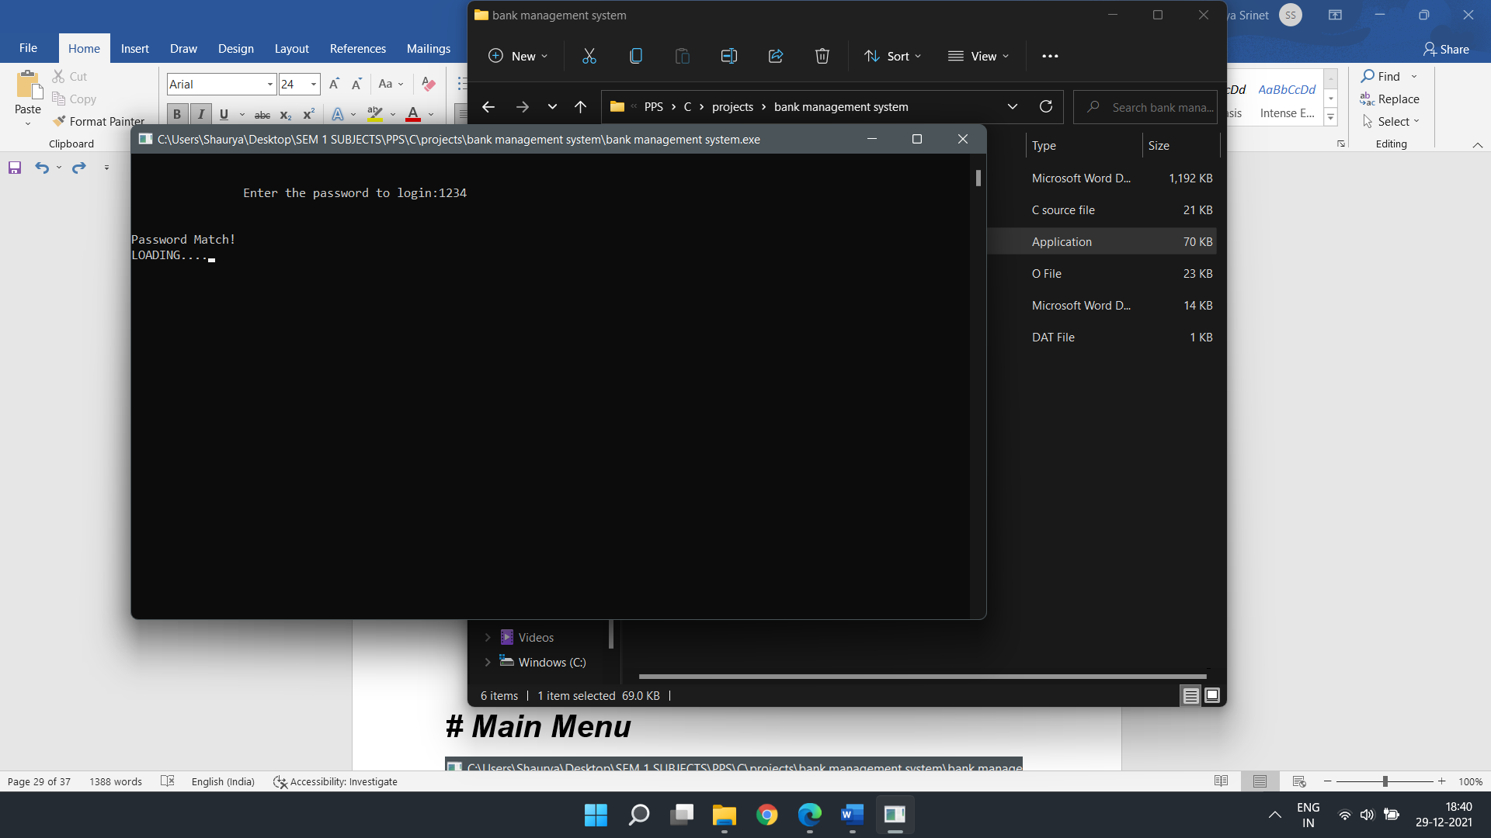

***# Main Menu***

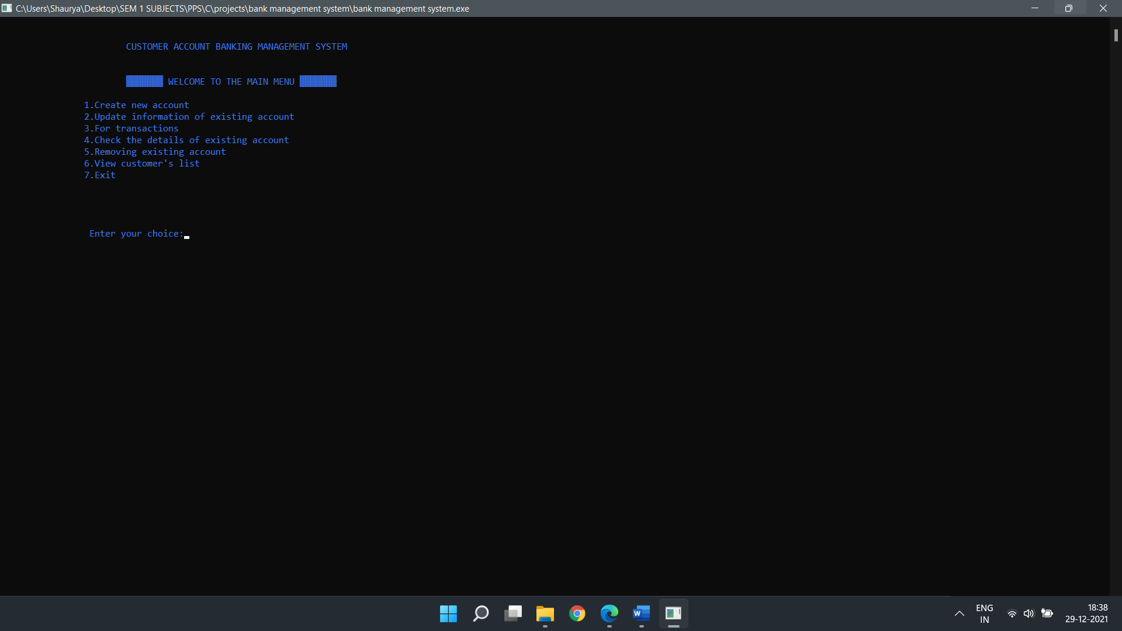

***(1) Creating an account***

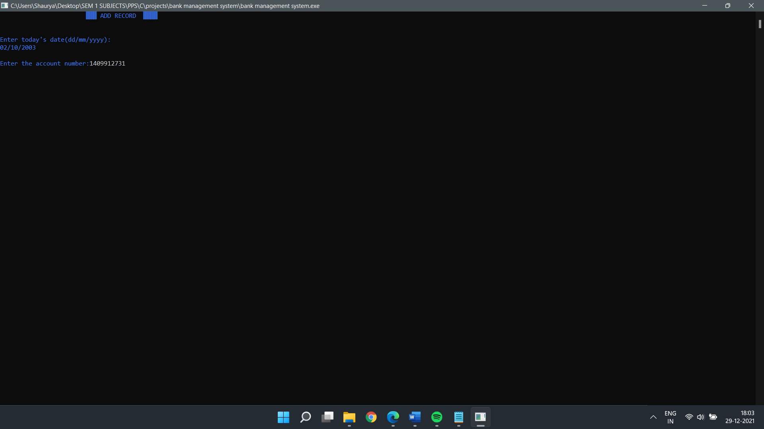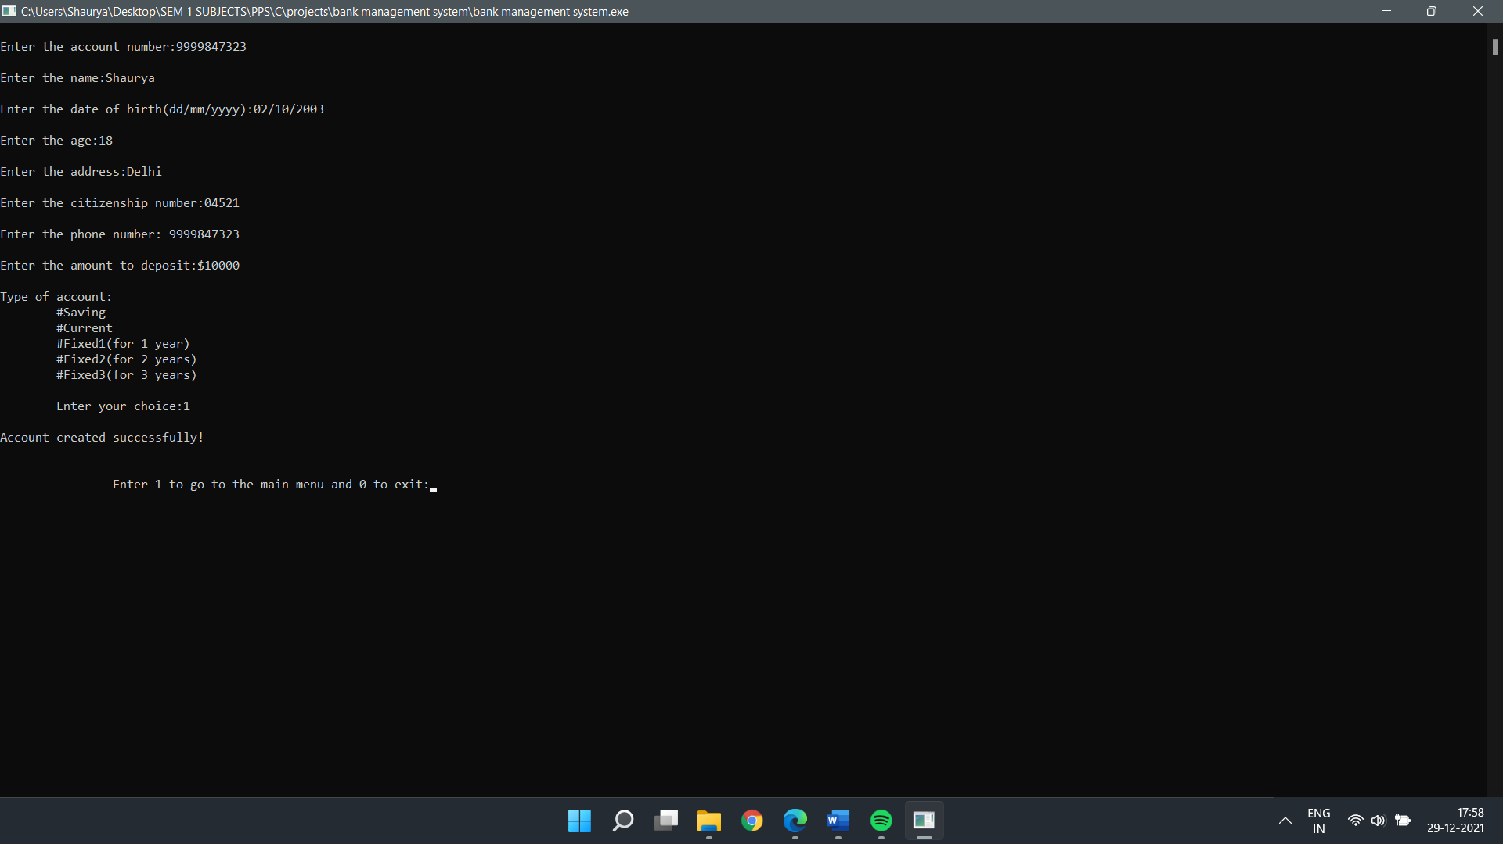

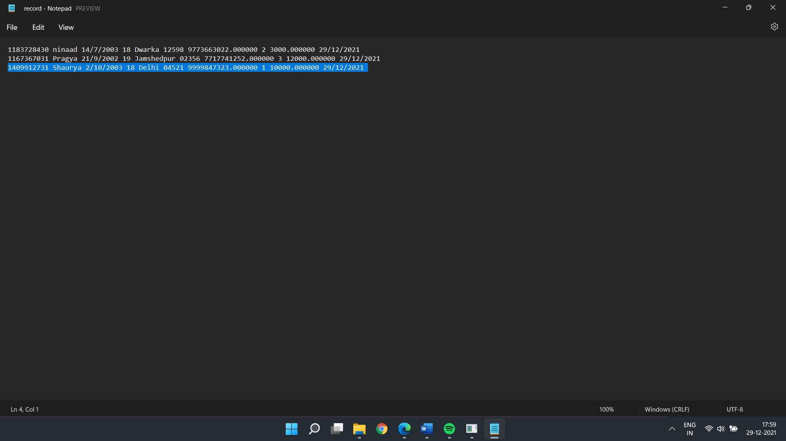

***(2) Updating account***

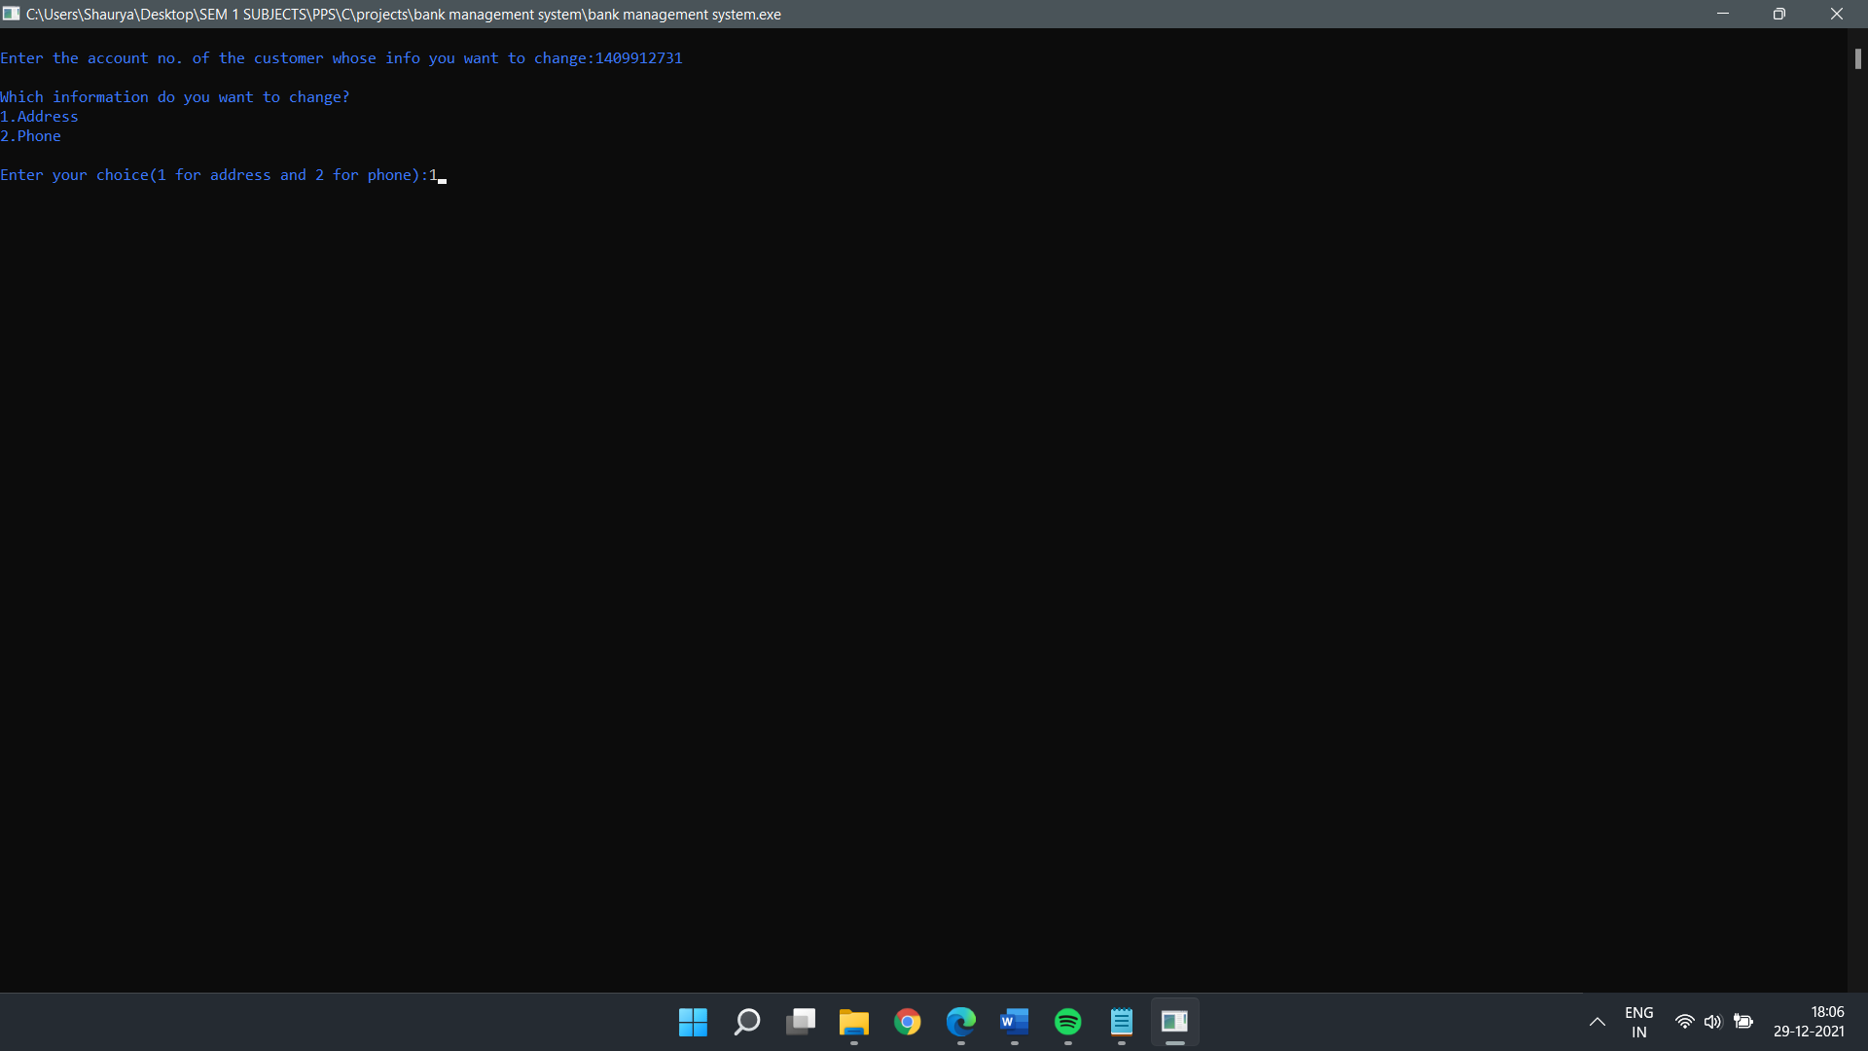

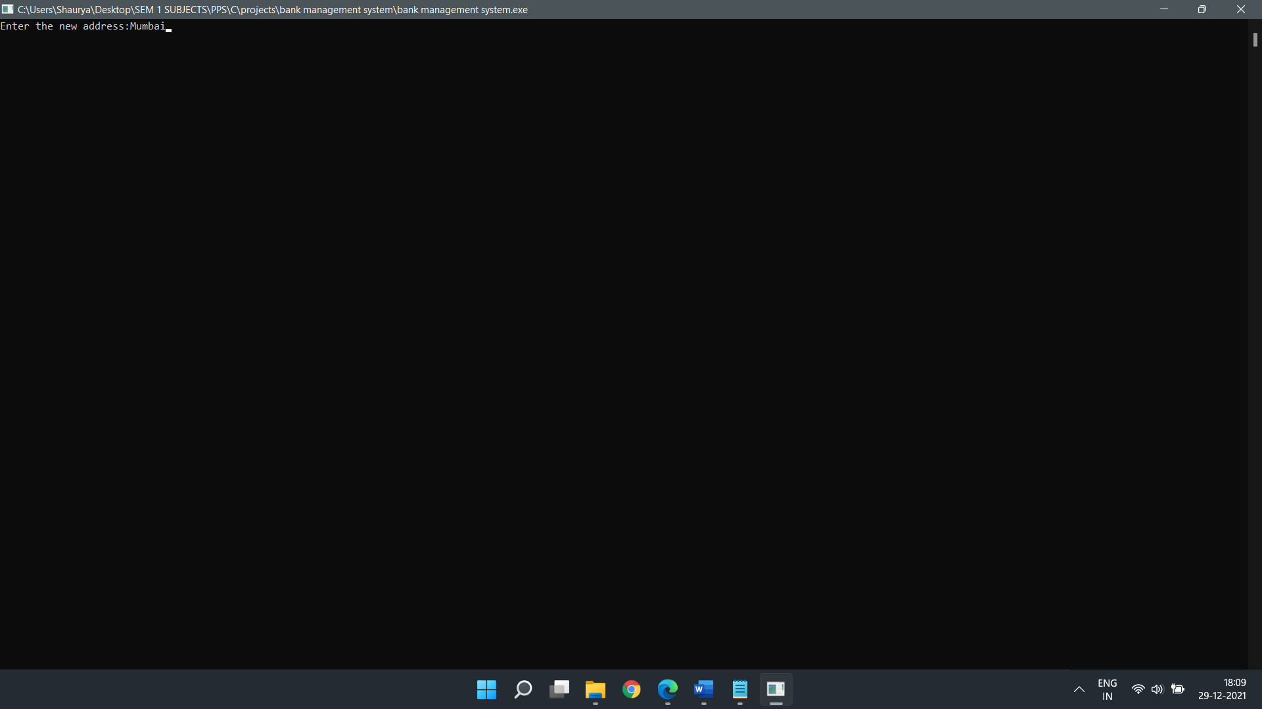

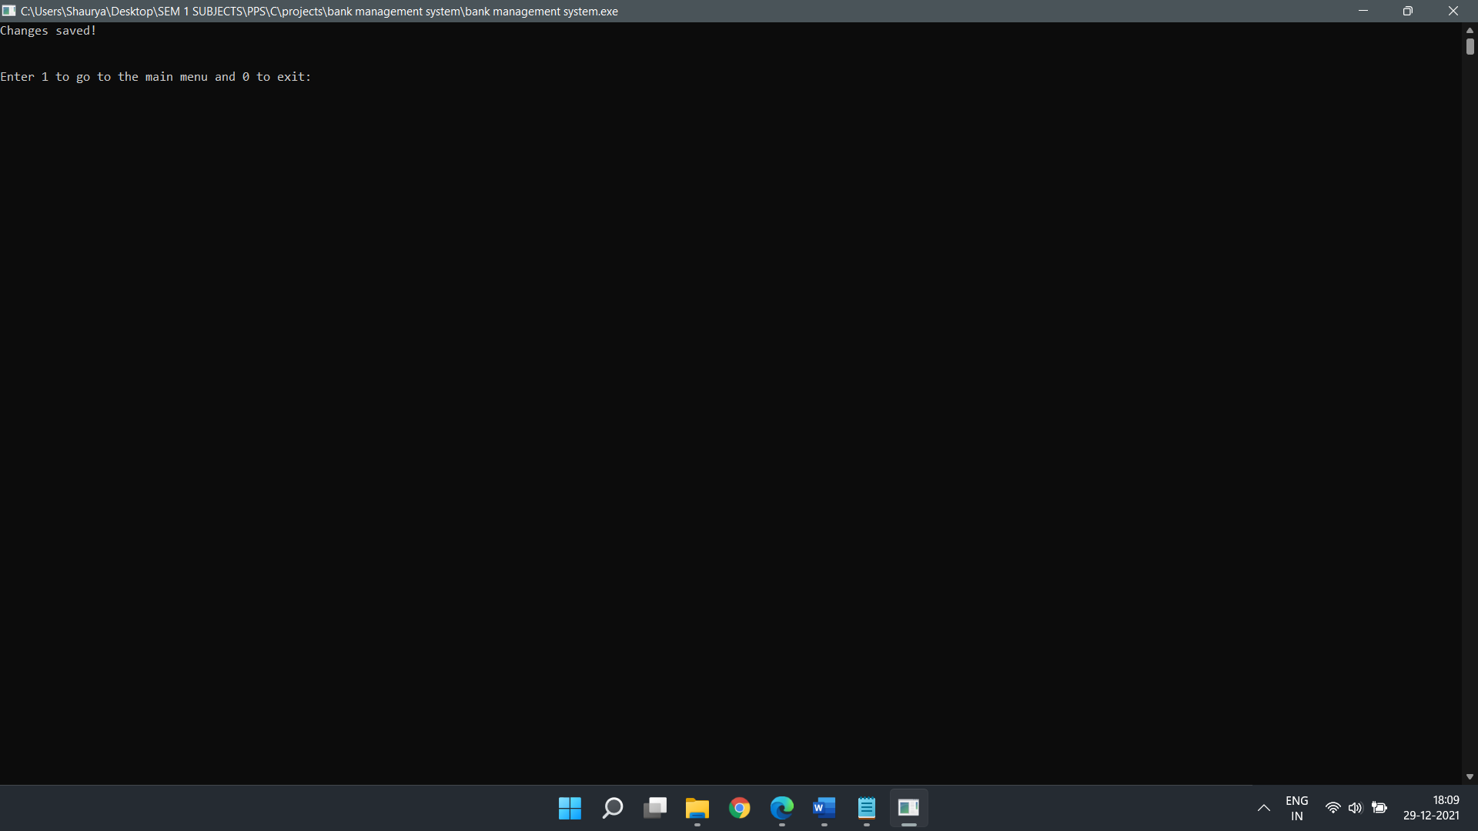

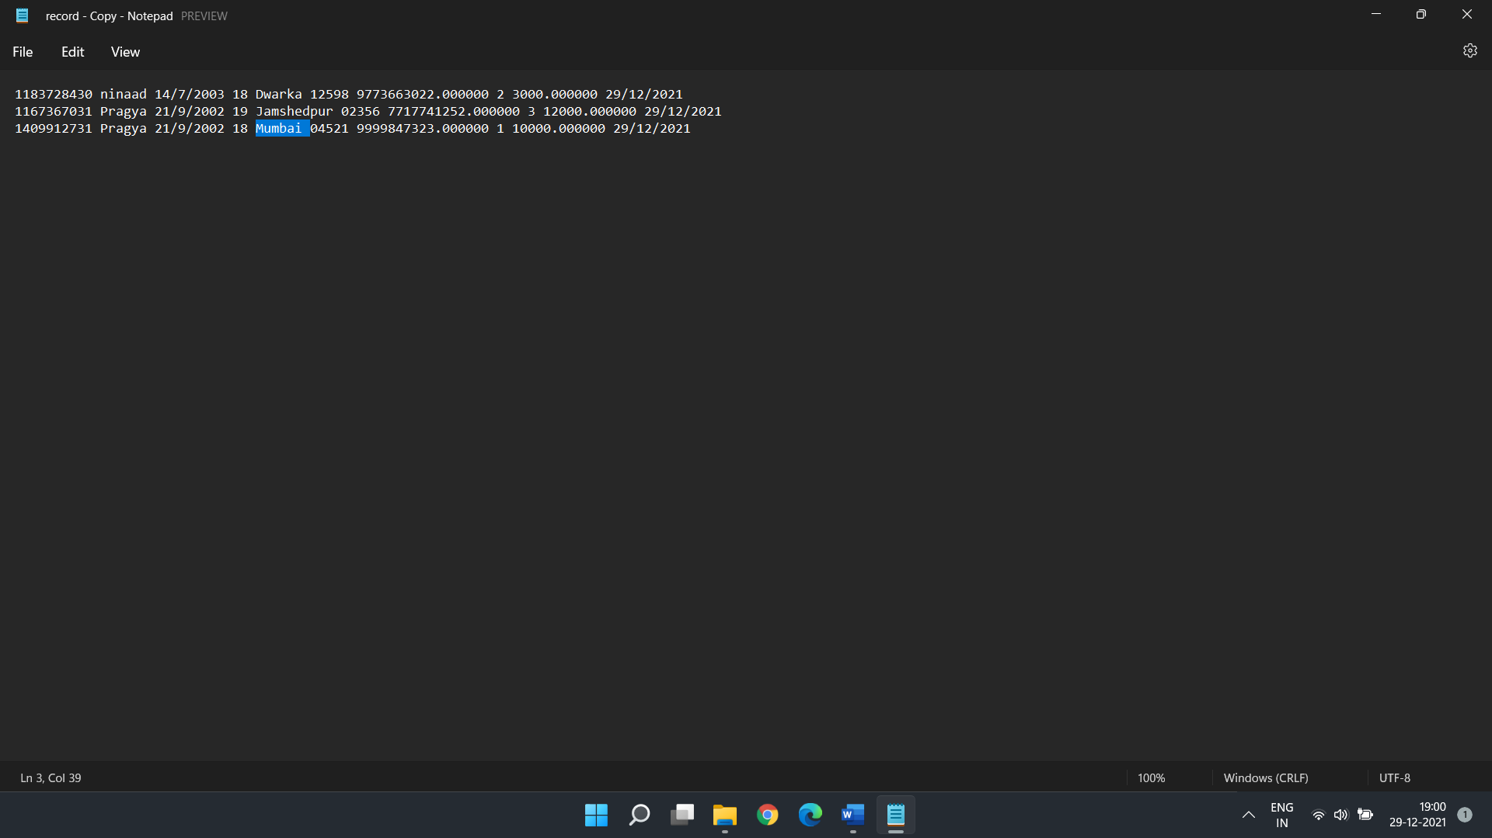

***(3.1) Transaction (Deposit)***

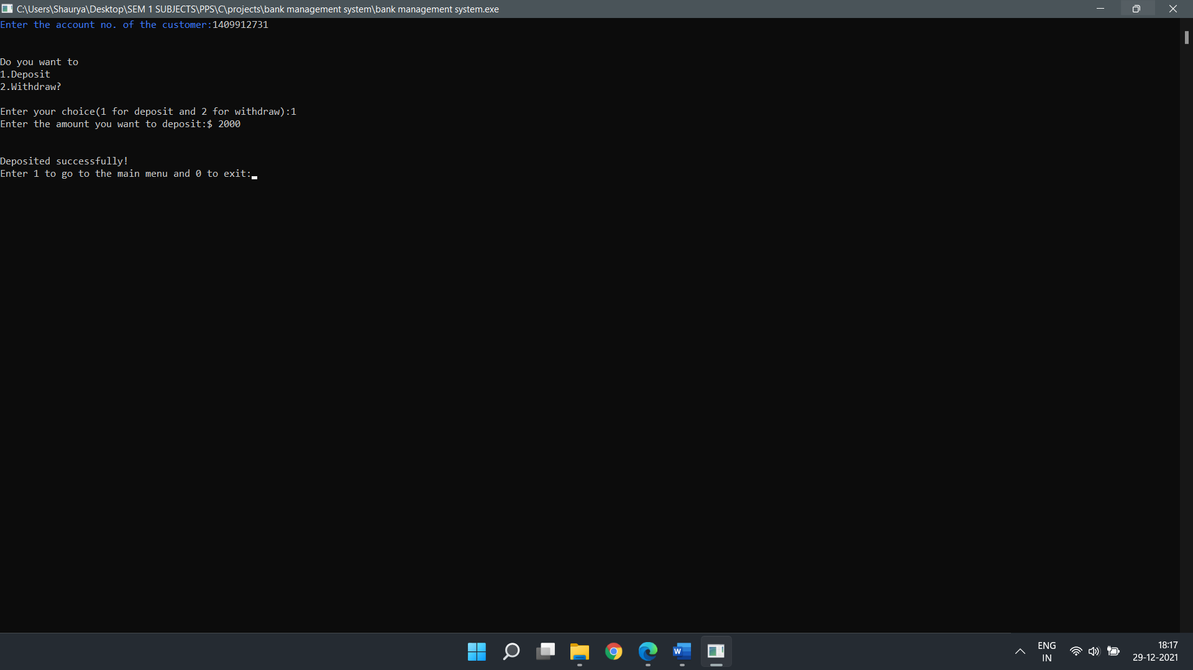

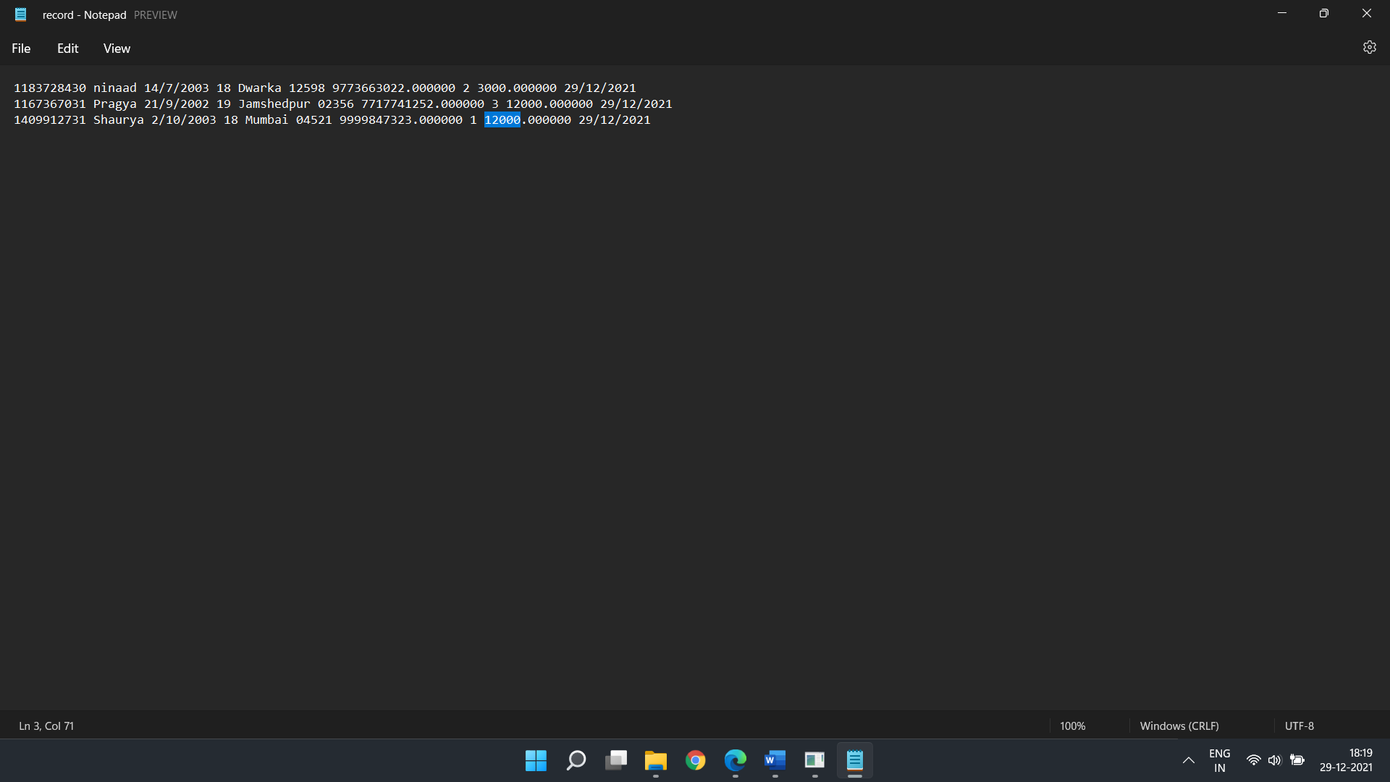

***(3.2) Transaction (Withdraw)***

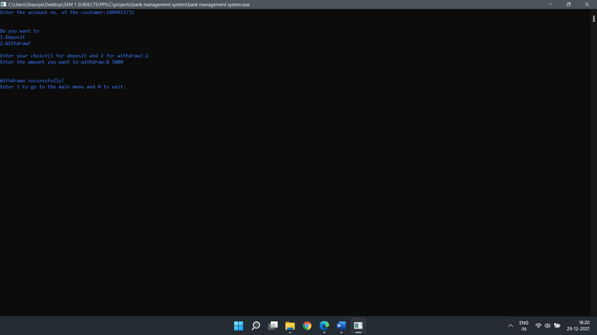

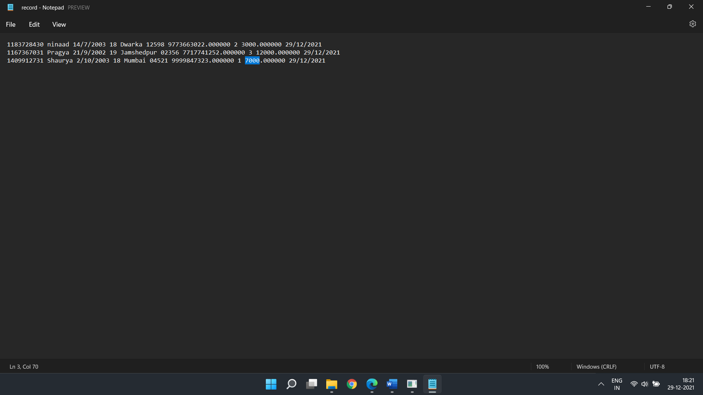

***(4) Details of a particular customer***

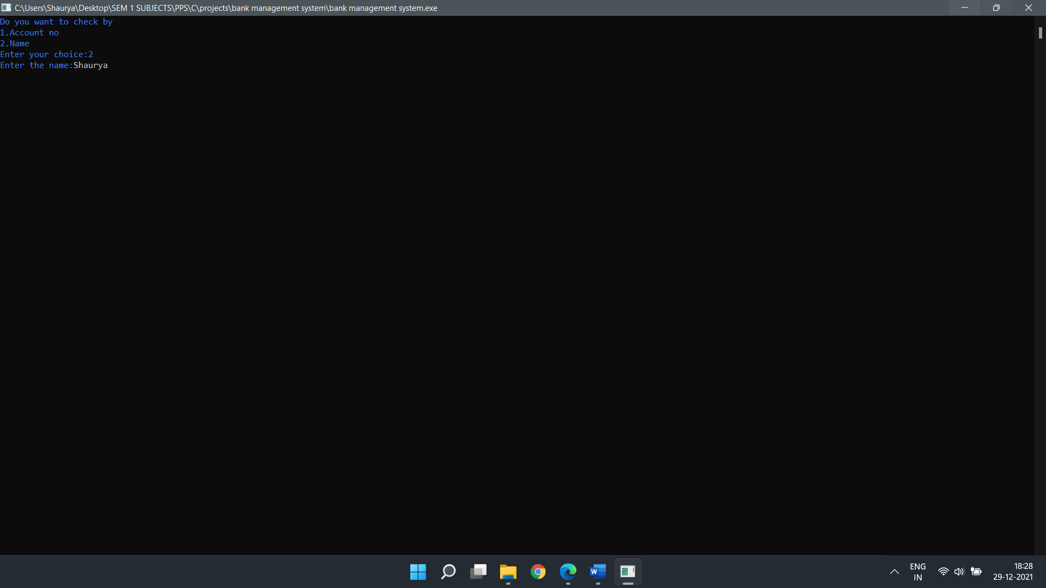

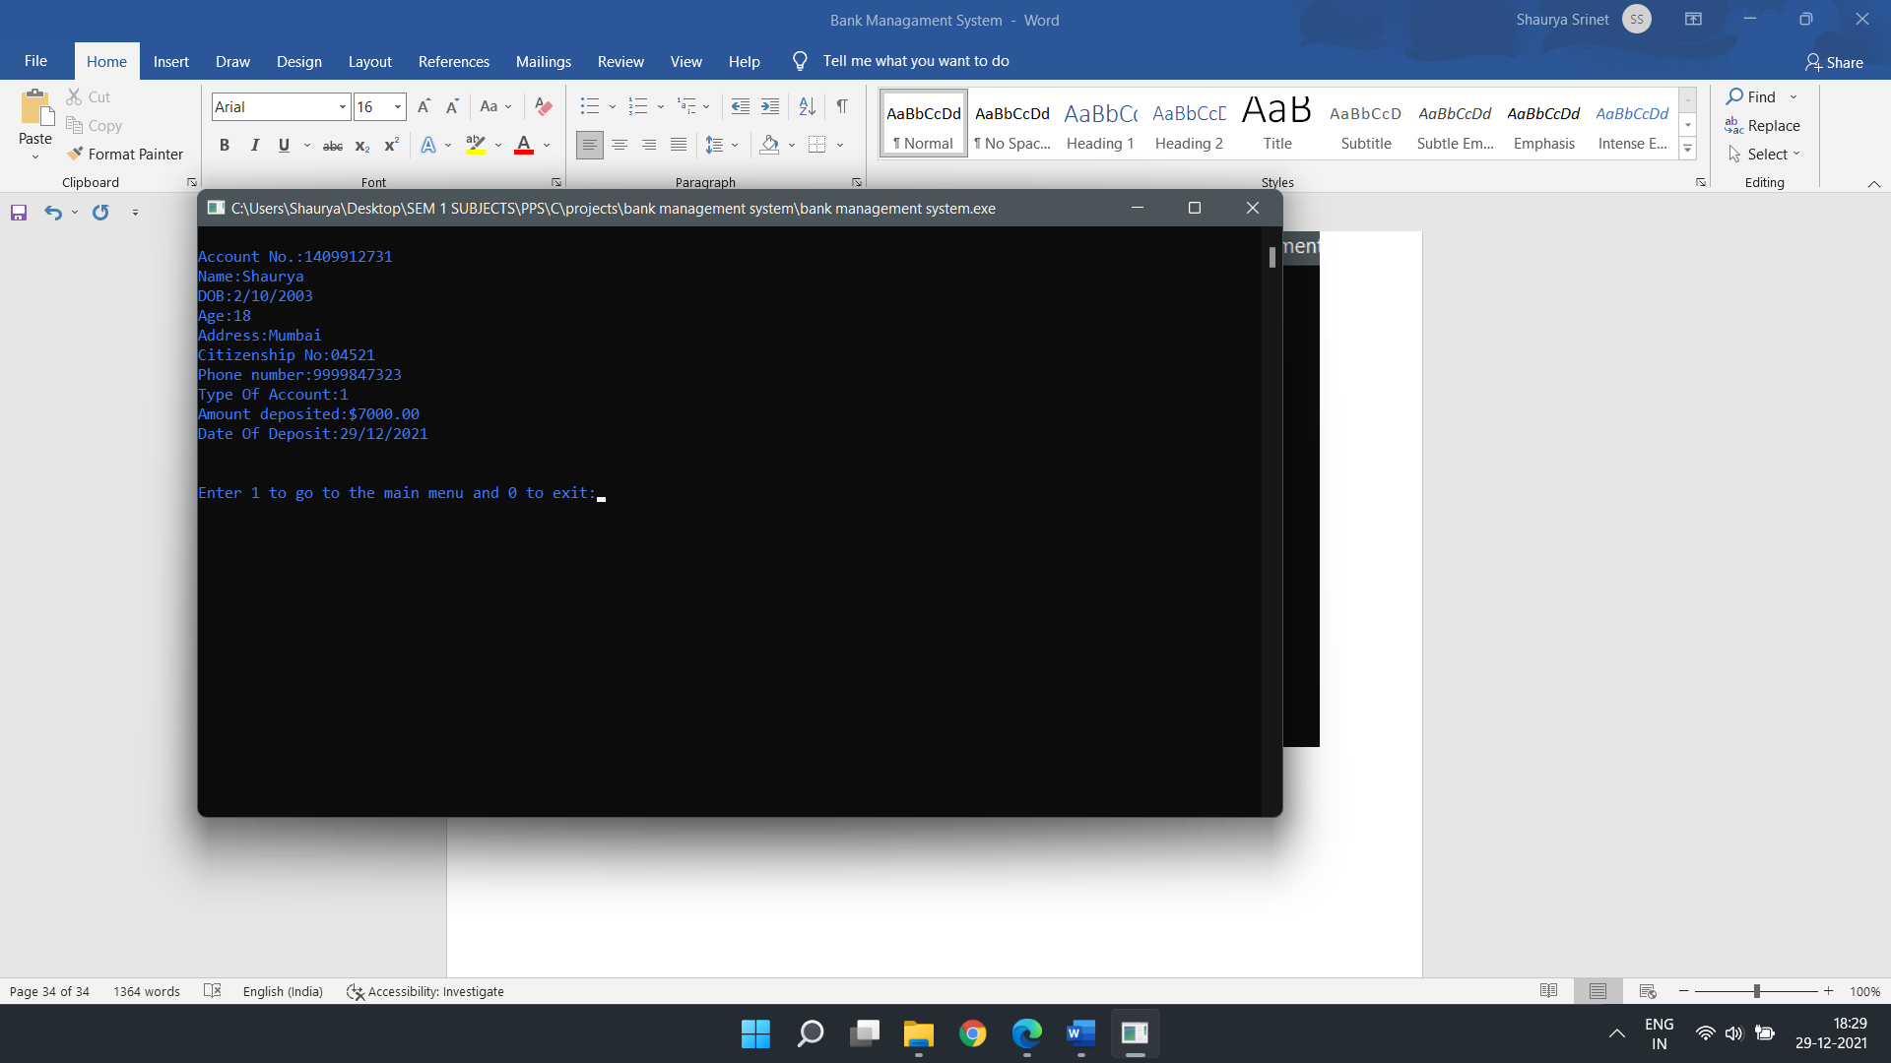

***(5) Deleting a bank account***

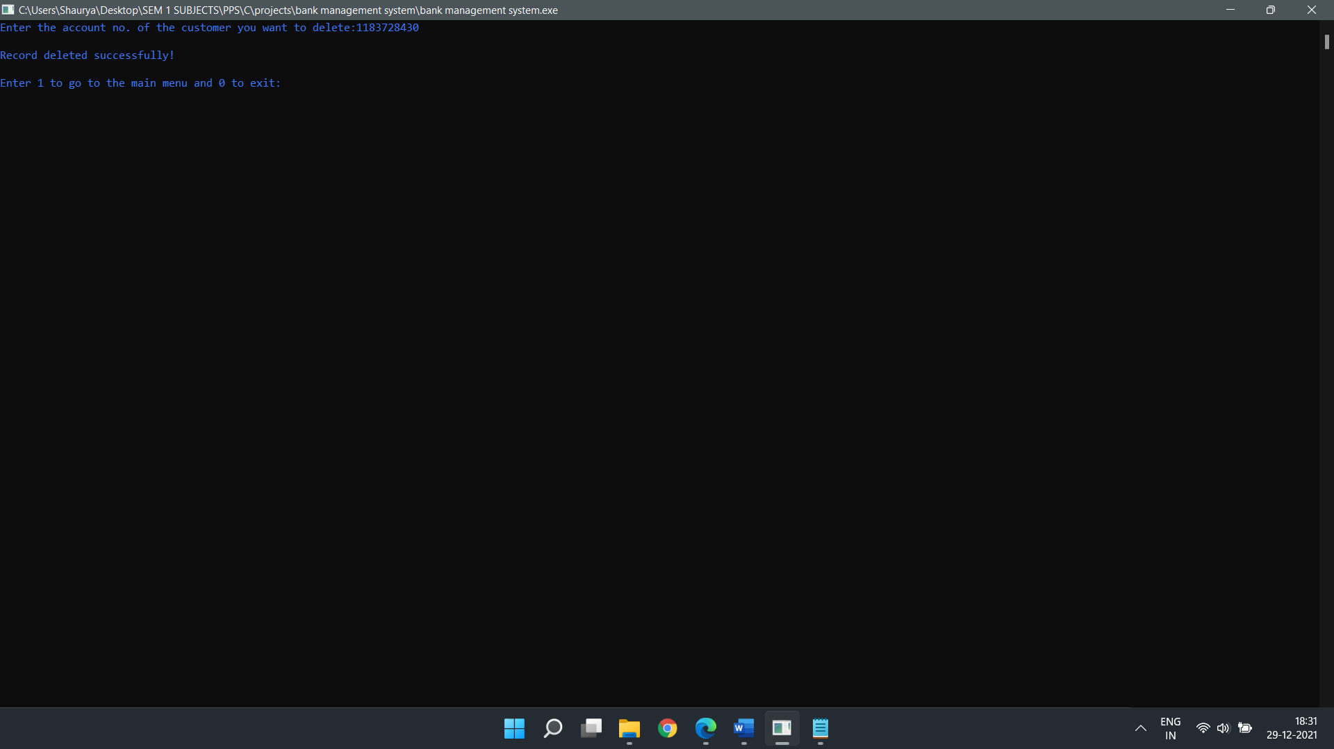

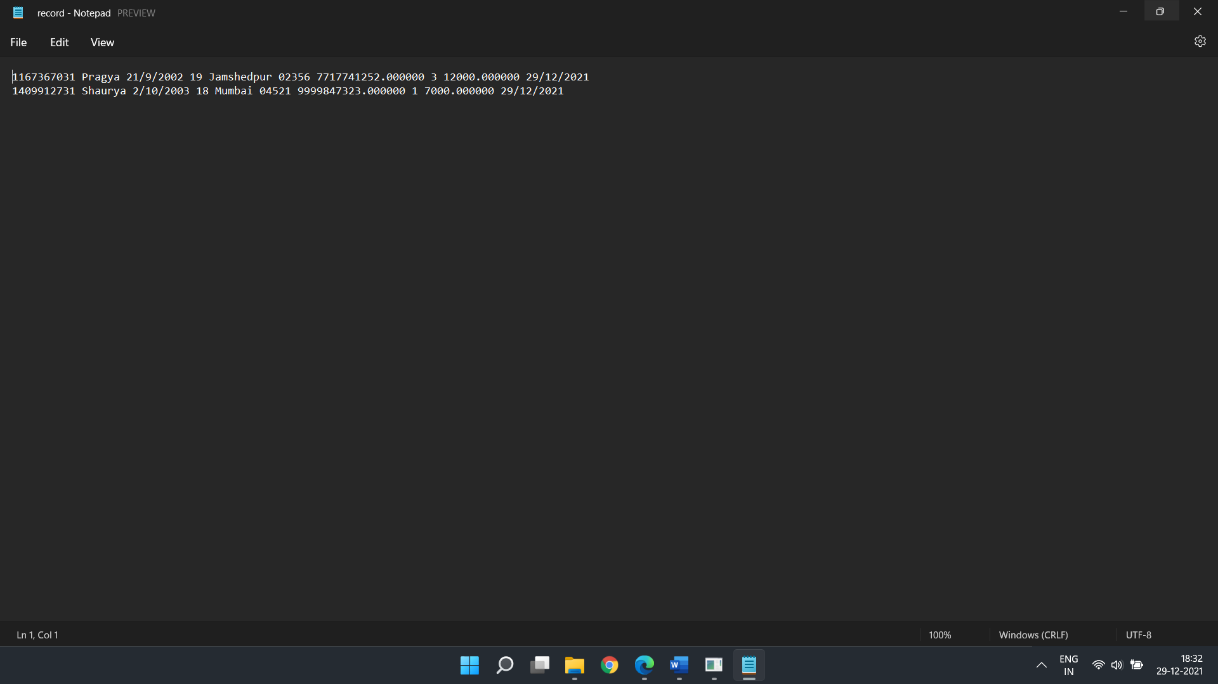

***(6) List of all customers registered in the system***

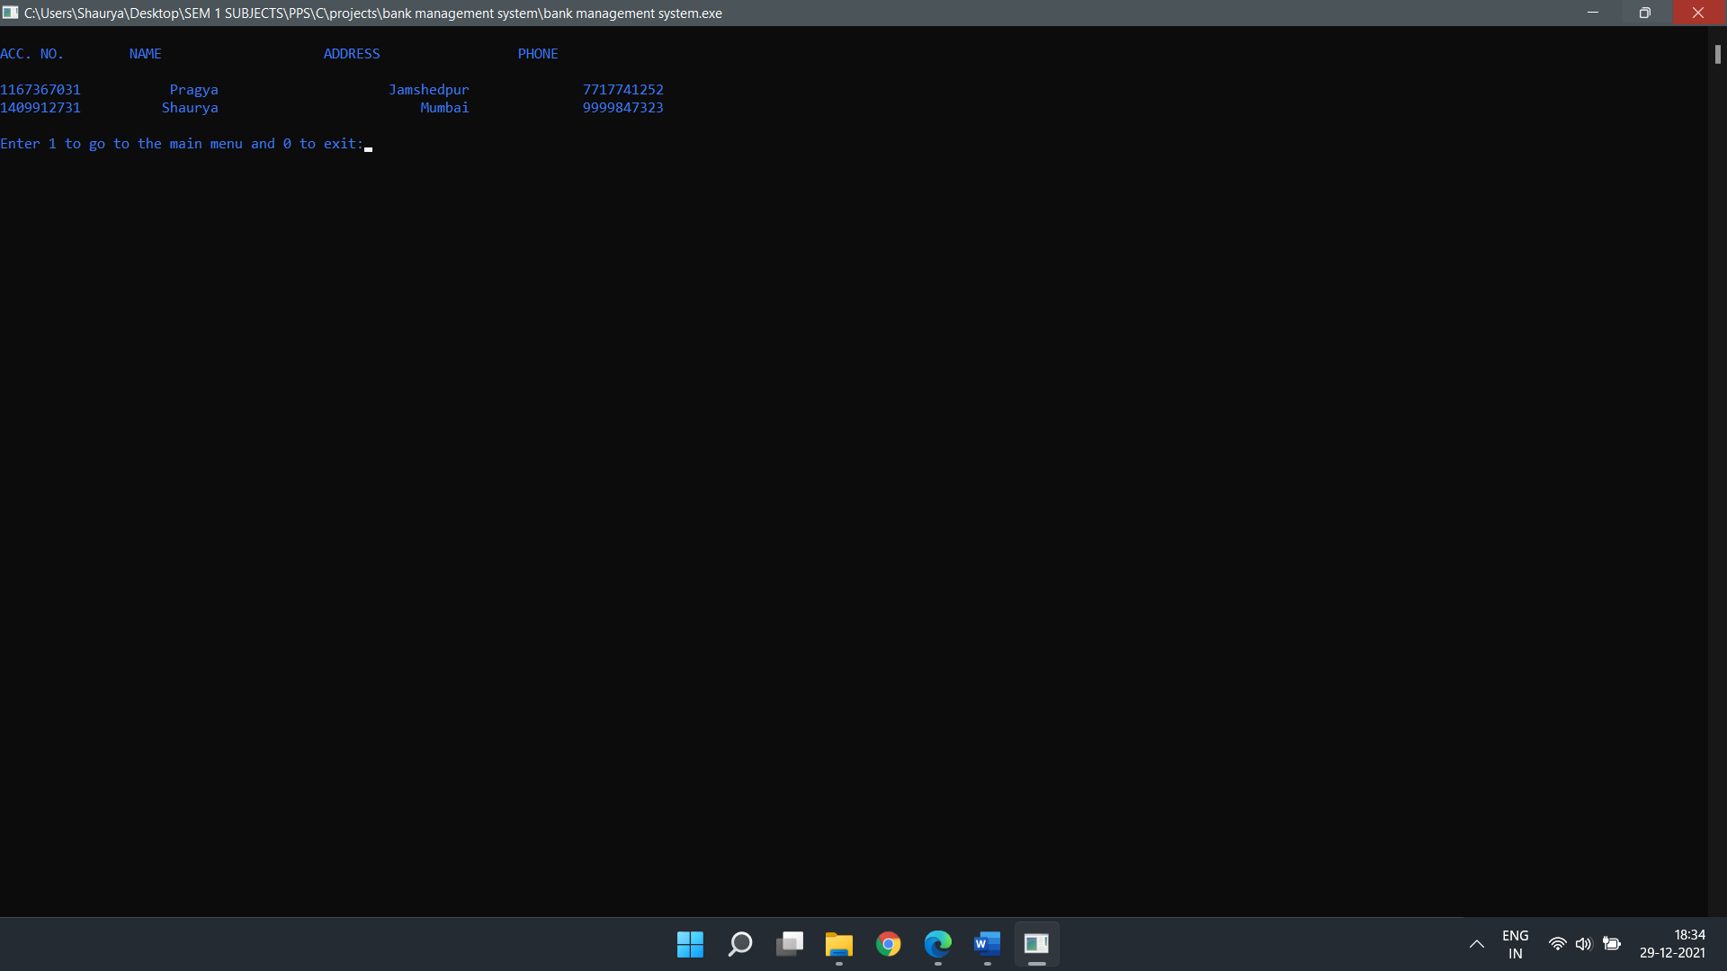

***(7) Exit***

